**Designing The AddReceptionistFrame**

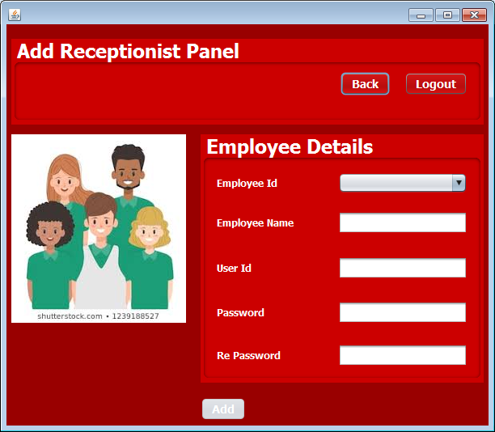

**STEPS TO BE DONE IN** **AddReceptionistFrame**

In the **AddReceptionistFrame** we need to do following steps:

1. Handle the constructor for proper initialization of class members

2. Allow the user to **logout**

3. Write code for the "**Add**" Button . When this button is clicked it should:

**a. Validate the inputs. If validation fails it should print the Error Message and return**

**b. It should fill all the details about the Receptionist in User POJO.**

**c. Update the remaining Receptionists JComboBox**

**d. Stop the user from adding more Receptionists**

4. Write code for the "**Done**" Button . When this button is clicked it should:

**a. Verify if all the Details have been set .If not, then it should ask the user to set all the Details and return.**

**b. If all Details have been set then it should make an entry in the USERS table and add the Receptionists to the USERS table.**

**c. Dispose the current frame and open the ManageOptionsFrame**

5. Write code for the "**Cancel**" Button . When this button is clicked it should:

a**. Dispose the current frame and open the ManageReceptionistFrame**

**THE TABLES USED IN AddReceptionistFrame**

**1.RECEPTIONISTS**

|  |  |  |
| --- | --- | --- |
| **Column Name** | **Data Type** | **Description** |
| **USERID** | **Varchar2(10)** | **Contains id of the user** |
| **EMPID** | **Varchar2(10)** | **Contains the employees id** |
| **PASSWORD** | **Varchar2(10)** | **Contains the Password** |
| **USERTYPE** | **Varchar2(10)** | **Contains the type of user ‘Manager’ or ‘Receptionist’** |
| **USERNAME** | **Varchar2(10)** | **Contains username of the user** |

**THE POJO CLASSES USED IN AddReceptionistFrame**

1. The **User** POJO

**THE DAO CLASSES USED IN AddReceptionistFrame**

1. The **UserDAO**

2. The **ReceptionistDAO**

We will call the method **addReceptionist( )** of **ReceptionistDAO** to add the **Receptionist** object in the **USERS** table.

**Handling the constructor:**

The constructor should do the following:

1. Display the username
2. Create a **User** object
3. Save the **Receptionist** object passed by **AddreceptionistFrame** for further use

**Allowing The User To Logout**

Same as AdminOptionsFrame